SINGLE LINKED LIST

Array contains following limitations:
- The size of array must be known in advance before using it in the program.
- Increasing size of the array is a time taking process. It is almost impossible to expand the size of the array at run time.
- All the elements in the array need to be contiguously stored in the memory. Inserting any element in the array needs shifting of all its predecessors.
Linked list is the data structure which can overcome all the limitations of an array. Using linked list is useful because,
- It allocates the memory dynamically. All the nodes of linked list are non-contiguously stored in the memory and linked together with the help of pointers.
- Sizing is no longer a problem since we do not need to define its size at the time of declaration. List grows as per the program's demand and limited to the available memory space.
Types of linked list:
1.single linked list
2.Double linked list
3.circular linked list

DEFINITION:
A single linked list is a ordered set of elements in which every element has a link to its next element in sequence. singly linked list can be traversed only in one direction
Each element in a linked list is called a node. A single node contains data and a pointer to the next node which helps in maintaining the structure of the list.

NULL
4
3
2
1

Head/start node
A linked list is formed when nodes are linked together to form a chain.Each node points to the next node present in the order.The first node is used to reference to traverse the list and

Data Address of
Next Element
is called Head.The last node points to NULL.
Structure of a node in linked list:
class Node:
def __init__(self, data):
self.data = data # The data stored in the node
self.next = None # Pointer to the next node (initially None)Operations on the single linked list:

- createList(): To create the list with ‘n’ number of nodes initially as defined by the user.
- traverse(): To see the contents of the linked list, it is necessary to traverse the given linked list. The given traverse() function traverses and prints the content of the linked list.
- insertAtBegin(): This function simply inserts an element at the front/beginning of the linked list.
- insertAtEnd(): This function inserts an element at the end of the linked list.
- insertAtPosition(): This function inserts an element at a specified position in the linked list.
- deleteFirst(): This function simply deletes an element from the front/beginning of the linked list.
- deleteEnd(): This function simply deletes an element from the end of the linked list.
- deletePosition(): This function deletes an element from a specified position in the linked list.
- Display():This function displays the elements in the list

Creating a node: To create a node allocate space in memory using these functions
Algorithm:

- Step1:Declare a pointer to node type variable to store link of first node of linked list. Say struct node *head;.
- Step2:Declare two more variables of node type, say struct node *newNode, *temp;
- step3:create our first node i.e. head node. Use dynamic memory allocation to allocate memory for a node. Say head = (struct node*)malloc(sizeof(struct node));
- Step4:Input data from user and assign to head using
- head->data = data;.
- Step5:At first head node points to NULL. Hence, assign
- head->next = NULL;.
say temp = head.
- step6: Allocate memory and assign memory reference to newNode, newNode = (struct node*)malloc(sizeof(structnode));
- step7: Read data and assign to data of new node.
newNode->data = data;
- Step8: Now link previous node with newly created node
- temp->next = newNode;
- Step9: Make current node as previous node using
temp = temp->next;
- Repeat the steps 6 to 9.

Pseudocode:

class Node:
def __init__(self, data):
self.data = data
self.next = None

class LinkedList:
def __init__(self):
self.head = None # Initialize the head of the list

def create_from_input(self):
n = int(input("Enter the number of nodes: "))
if n <= 0:
print("List size must be greater than 0.")
return

# Create the first node
data = int(input("Enter data for node 1: "))
self.head = Node(data)
current = self.head

# Create the rest of the nodes
for i in range(2, n + 1):
data = int(input(f"Enter data for node {i}: "))
current.next = Node(data)
current = current.next

def display(self):
if not self.head:
print("The list is empty.")
return

current = self.head
while current:
print(current.data, end=" -> ")
current = current.next
print("None")

# Example usage
ll = LinkedList()
ll.create_from_input()
print("The linked list is:")
ll.display()
Insertions

There are three possible positions where we can enter a new node in a linked list
- Insertion at beginning
- Insertion at a specific position
- Insertion at end

Insertion at the Beginning:

If we want to insert anode at the beginning of the linked list.

Algorithm:
- Step 1 - Create a newNode with given value.
- Step 2 - Check whether list is Empty (head == NULL)
- Step 3 - If it is Empty then, set newNode→next = NULL and head = newNode.
- Step 4 - If it is Not Empty then, set newNode→next = head and head = newNode.

consider an example where a newnode with data value 10 is to be inserted at the beginning of linked list. First create a newnode and assign data value 10 and newnode ->next=NULL.

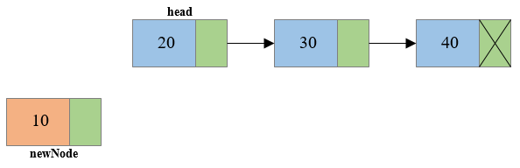

If the head is not empty then set newnode->next to head.
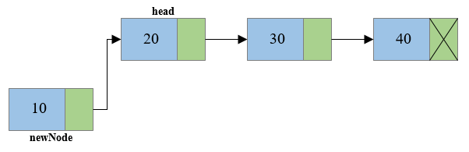
And make the newnode as head

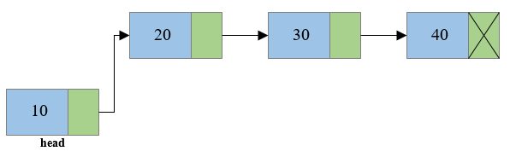

Pseudocode :
class Node:
def __init__(self, data):
self.data = data
self.next = None

class LinkedList:
def __init__(self):
self.head = None

def insert_at_beginning(self, data):
new_node = Node(data)
new_node.next = self.head
self.head = new_node

def insert_at_end(self, data):
new_node = Node(data)
if not self.head: # If the list is empty
self.head = new_node
return
current = self.head
while current.next: # Traverse to the last node
current = current.next
current.next = new_node

def insert_at_position(self, data, position):
new_node = Node(data)
if position <= 0: # Insert at the beginning for invalid position
self.insert_at_beginning(data)
return

current = self.head
for _ in range(position - 1):
if not current: # If position is beyond the list's length
print("Position out of bounds")
return
current = current.next

new_node.next = current.next
current.next = new_node

def display(self):
if not self.head:
print("The list is empty.")
return
current = self.head
while current:
print(current.data, end=" -> ")
current = current.next
print("None")

ll.display()
Insertion at a given Position

If we want to insert a node at a specific position.
Algorithm:
- Step 1 - Create a newnode with given value.
- Step 2 - Check whether list is Empty (head == NULL)
- Step 3 - If it is Empty then,
- set newNode → next = NULL and head = newNode.
- Step 4 - If it is Not Empty then, define a node pointer temp and initialize with head.
- Step 5 - Keep moving the temp to its next node until it reaches to the node after which we want to insert the newNode (until temp1 → data is equal to location, here location is the node value after which we want to insert the newNode).
- Step 6 - Every time check whether temp is reached to last node or not. If it is reached to last node then display 'Given node is not found in the list!!! Insertion not possible!!!' and terminate the function. Otherwise move the temp to next node.
- Step 7 - Finally, Set 'newNode → next = temp → next' and 'temp → next = newNode'

Consider an example of inserting a newnode with data 30 in location 3.create a newnode

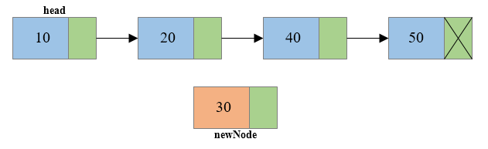

Traverse the node pointer temp till the location and make newnode pointer points to temp->next
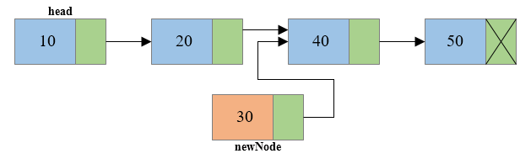
Then set temp->next to newnode
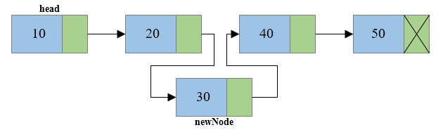

Pseudocode:
class Node:
def __init__(self, data):
self.data = data
self.next = None

class LinkedList:
def __init__(self):
self.head = None

def insert_at_position(self, data, position):
new_node = Node(data)

# If inserting at the beginning
if position <= 0 or not self.head:
new_node.next = self.head
self.head = new_node
return

# Traverse to the node just before the given position
current = self.head
for _ in range(position - 1):
if not current.next: # If the position is beyond the current list length
break
current = current.next

# Insert the new node
new_node.next = current.next
current.next = new_node

def display(self):
if not self.head:
print("The list is empty.")
return
current = self.head
while current:
print(current.data, end=" -> ")
current = current.next
print("None")

Algorithm:
- Step 1 - Create a newNode
newNode → next = NULL.
- Step 2 - If list Empty then(head == NULL).
- Step 3 - set head = newNode.
- Step 4 - If it is Not Empty then, define a node pointer temp = head.
- Step 5 - Keep moving the temp to its next node until it reaches to the last node in the list until
( temp → next =NULL).
- Step 6 - Set temp → next = newNode.
Consider an example of inserting a node with data 40 at end of linkedlist. Create the newnode and assign data to it. 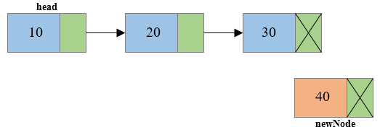
temp
Consider a node pointer temp which points to head and move the pointer until
(temp->next=NULL) then make temp->next =newnode
temp
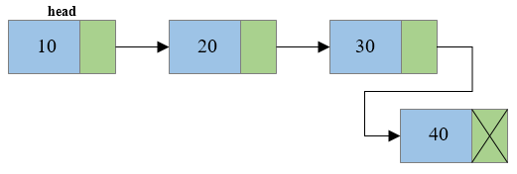

Pseudocode:
class Node:
def __init__(self, data):
self.data = data
self.next = None

class LinkedList:
def __init__(self):
self.head = None

def insert_at_end(self, data):
new_node = Node(data)
if not self.head: # If the list is empty
self.head = new_node
return
current = self.head
while current.next: # Traverse to the last node
current = current.next
current.next = new_node

def display(self):
if not self.head:
print("The list is empty.")
return
current = self.head
while current:
print(current.data, end=" -> ")
current = current.next
print("None")

Deletions
There are three possible cases for deletion
- Deletion at beginning
- Deletion of node in nth position
- Deletion at end
Delete from Beginning:
Algorithm:
- Step 1 - Check whether list is Empty (head == NULL)
- Step 2 - If it is Empty then, display 'List is Empty!!!
- Step 3 - Else define a Node pointer 'temp' and initialize with head.
- Step 4 - If list is having only one node
(temp → next == NULL)
- Step 5 - If it is TRUE then set head = NULL and delete temp
- Step 6 - If it is FALSE then set head = temp → next, and delete temp.
Consider an example of deleting the first node from the given linked list
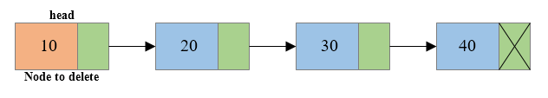Take a node pointer temp and point it to first node make temp->next=NULL
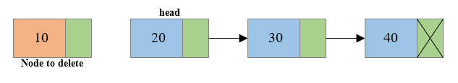
temp
And make temp->next=head

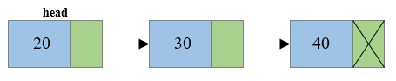
Pseudocode:
class Node:
def __init__(self, data):
self.data = data
self.next = None

class LinkedList:
def __init__(self):
self.head = None

def insert_at_end(self, data):
new_node = Node(data)
if not self.head:
self.head = new_node
return
current = self.head
while current.next:
current = current.next
current.next = new_node

def remove_at_beginning(self):
if not self.head: # If the list is empty
print("The list is empty. Nothing to remove.")
return
self.head = self.head.next # Move the head to the next node

def display(self):
if not self.head:
print("The list is empty.")
return
current = self.head
while current:
print(current.data, end=" -> ")
current = current.next
print("None")

Delete from a specific Position:
Algorithm:
- Step 1 - If list is Empty then (head == NULL)
- Step 2 - If it is Empty then, display 'List is Empty!!!
- Step 3 –Else define two Node pointers temp1,temp2 and
- temp1=head;
- Step 4 - Keep moving the temp1 until it reaches to the exact node to be deleted or to the last node. And every time set 'temp2 = temp1' before moving the 'temp1' to its next node.
- Step 5 - If it is reached to the last node then display” Deletion not possible”.
- Step 6 - If it is reached to the exact node which we want to delete, then check whether list is having only one node or not

Consider an example of deleting node with data value 30.which is in position 3. Take two pointers temp1 and temp2 and point them to head
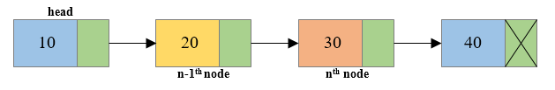
temp1 temp2
Move temp1 until it reaches the node to be deleted i.e. till nth position and every time set 'temp2 = temp1' before moving the 'temp1' to its next node i.e.temp2 the list will be in n-1 th position i.e. 2nd position

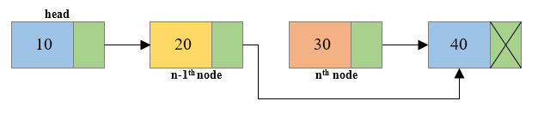
temp2 temp1

Then make temp1->next=NULL and temp2->next=temp1->next .
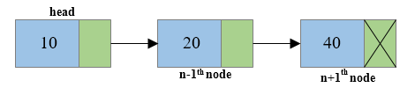

Pseudocode:
class Node:
def __init__(self, data):
self.data = data
self.next = None

class LinkedList:
def __init__(self):
self.head = None

def insert_at_end(self, data):
new_node = Node(data)
if not self.head:
self.head = new_node
return
current = self.head
while current.next:
current = current.next
current.next = new_node

def delete_at_position(self, position):
if not self.head: # If the list is empty
print("The list is empty. Nothing to delete.")
return

# If deleting the first node
if position == 0:
self.head = self.head.next
return

# Traverse to the node before the one to delete
current = self.head
for _ in range(position - 1):
if not current.next: # If position is out of bounds
print("Position out of bounds.")
return
current = current.next

if not current.next: # If there's no node at the given position
print("Position out of bounds.")
return

# Skip the node at the given position
current.next = current.next.next

def display(self):
if not self.head:
print("The list is empty.")
return
current = self.head
while current:
print(current.data, end=" -> ")
current = current.next
print("None")

Delete at end:
- Step 1 - Check whether list is Empty (head == NULL)
- Step 2 - If it is Empty then, display 'List is Empty!!!
- Step 3 - If it is Not Empty then, define two Node pointers 'temp1' and 'temp2' and initialize 'temp1= head.
- Step 4 - Check whether list has only one Node (temp1 → next == NULL)
- Step 5 - If it is TRUE. Then, set head = NULL and delete temp1
- Step 6 - If it is FALSE. Then, set 'temp2 = temp1 ' and move temp1 to its next node. Repeat the same until it reaches to the last node in the list. (until temp1 → next == NULL)
- Step 7 - Finally, Set temp2 → next = NULL and delete temp1.
Consider the example of deleting the last node i.e. node with data value 40 from the given list.consider two pointers traverse the list by taking a two pointers temp1 and temp2 which initially points to Head.
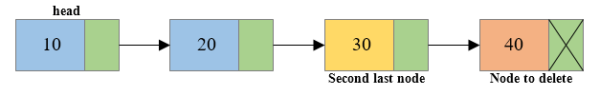
temp1 temp2
Move temp1 until it reaches the node to be deleted i.e. till end of list and every time set 'temp2 = temp1' before moving the 'temp1' to its next node i.e.temp2 the list will be in n-1 th position .
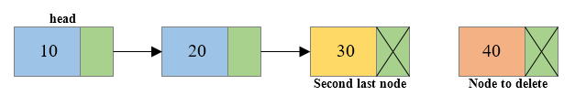
temp2 temp1

free temp1and make temp2->next=NULL.
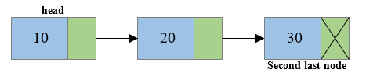
class Node:
def __init__(self, data):
self.data = data
self.next = None

class LinkedList:
def __init__(self):
self.head = None

def insert_at_end(self, data):
new_node = Node(data)
if not self.head: # If the list is empty
self.head = new_node
return
current = self.head
while current.next: # Traverse to the last node
current = current.next
current.next = new_node

def remove_at_end(self):
if not self.head: # If the list is empty
print("The list is empty. Nothing to remove.")
return

# If there's only one node in the list
if not self.head.next:
self.head = None
return

# Traverse to the second last node
current = self.head
while current.next.next:
current = current.next

# Remove the last node
current.next = None

def display(self):
if not self.head:
print("The list is empty.")
return
current = self.head
while current:
print(current.data, end=" -> ")
current = current.next
print("None")

Display:
Displaying the contents of a linked list is very simple. We keep moving the temp node to the next one and display its contents.
Algorithm:
- Step 1 - Check whether list is Empty (head == NULL)
- Step 2 - If it is Empty then, display 'List is Empty‘
- Step 3 - Else define a Node pointer temp and temp= head.
- Step 4 - Keep displaying temp → data until temp reaches to the last node
- Step 5 - Finally display temp → data.
Consider the following linked list.Take a node pointer temp which points to head.while (temp!=NULL) display the data of the nodes.
temp

Pseudocde:
def display(self):
# Step 1: Check if the list is empty
if not self.head:
print("\nList is Empty\n")
return

# Step 2: Define a temporary pointer (temp) and start from head
temp = self.head
print("\n\nList elements are - ")

# Step 3: Traverse and display until the last node
while temp.next:
print(f"{temp.data} --->", end=" ")
temp = temp.next

# Step 4: Display the last node
print(f"{temp.data} ---> NULL")
Doubly Linked Lists
Doubly Linked Lists is the updated version of Singular Linked Lists. In doubly linked lists navigation is possible in both ways, either forward or backward. A Doubly Linked List (DLL) contains an extra pointer, typically called the previous pointer, together with the next pointer and data which are there in the singly linked list.
- Components of Node:
- Data − Each node of a Doubly linked list can store a data called an element.
- Next − Each node of a Doubly linked list contains the address of the next link called Next.
- Prev − Each node of a Double linked list contains the address of the previous link called Prev.
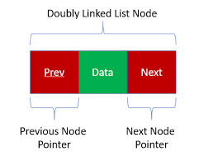
- How Doubly Linked Lists are represents:
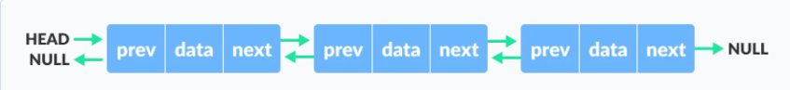

- Difference between Singular and Doubly Linked Lists:
Singular Linked Lists | Doubly Linked Lists
SLL nodes contains 2 field -data field and next link field. | DLL nodes contains 3 fields -data field, a previous link field and a next link field.
In SLL, the traversal can be done using the next node link only. Thus traversal is possible in one direction only. | In DLL, the traversal can be done using the previous node link or the next node link. Thus traversal is possible in both directions
Occupies Less memories. | Occupies more memories.
We mostly prefer to use singly linked list for the execution of stacks. | We can use a doubly linked list to execute heaps and stacks, binary trees.

- Basic Operations of Doubly Linked Lists:
- Insertion of node – at beginning, at end, at given position.
- Deletion of node – at beginning, at end, at given position.
- Display

- Node Creation:
struct node {
int data;
struct node *next, *prev;
};
- Insertion of a node at beginning of a Double Linked Lists:
- Create a new node temp
- Insert data into temp
- IF head is NULL:
Prev and next field of the node temp is NULL.
head=temp
- ELSE: next field of temp connect to head
Prev field of head connect to temp
Prev field of the node temp is NULL
- Head=temp

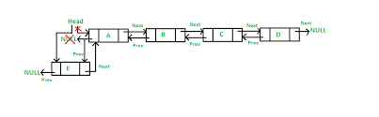

- Function:
- class DoublyLinkedList:
- def __init__(self):
- self.head = None

- def insert_beginning(self):
- # Step 1: Create a new node and ask for input
- item = int(input("\nEnter value for Node: "))
- temp = Node(item)

- # Step 2: If the list is empty
- if not self.head:
- temp.next = None # No next node as it's the only node
- self.head = temp # Set head to this node
- else:
- # Step 3: Insert at the beginning of the list
- temp.next = self.head # Point the new node's next to the current head
- self.head.prev = temp # Set the current head's prev to the new node
- self.head = temp # Move head to the new node

- def display(self):
- # Display the list
- if not self.head:
- print("\nList is Empty\n")
- return
- temp = self.head
- print("\nList elements are - ")
- while temp:
- print(f"{temp.data} <=>", end=" ")
- temp = temp.next
- print("NULL")

Insertion of a node at end of a Double Linked Lists:
1. Create a new node temp
2. Assign node Trav to the head.
3. Go to last node by using loop.
While(trav->next != NULL)
trav=trav->next
4. Insert data into temp and next part is NULL.
5. Connect trav to temp by next and prev pointer.
trav->next=temp
temp->prev=trav
temp->next=NULL

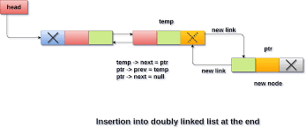
- Function:
- def insert_end(self):
- # Step 1: Create a new node and ask for input
- item = int(input("\nEnter value for Node: "))
- temp = Node(item)

- # Step 2: If the list is empty
- if not self.head:
- temp.next = None # No next node as it's the only node
- temp.prev = None # No previous node as it's the only node
- self.head = temp # Set head to this node
- else:
- # Step 3: Traverse to the last node
- trav = self.head
- while trav.next:
- trav = trav.next # Traverse until the last node

- # Step 4: Insert the new node at the end
- trav.next = temp # Link last node's next to the new node
- temp.prev = trav # Set new node's prev to the last node
- temp.next = None # Set new node's next to None as it's the last node
- Insertion of a node at given position of a Double Linked Lists:
  - Create a new node temp.
  - Insert data into temp.
  - Assign : pos
  - Assign node trav to the head.
  - Traversal trav till pos-1.
while(i<pos-1)
trav=trav->next
i++
  - Connect node temp to next node of node trav and trav.
  - Connect trav to the node temp.
temp->next=trav->next;
temp->prev=trav;
trav->next->prev=temp;
trav->next=temp;

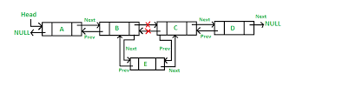
- Function:
- def insert_position(self):
- # Step 1: Ask for user input to create a new node
- item = int(input("\nEnter value for Node: "))
- pos = int(input("\nEnter position to insert a new node: "))
- temp = Node(item)

- # Step 2: If the list is empty
- if not self.head:
- temp.next = None
- temp.prev = None
- self.head = temp

- # Step 3: If the position is 1 (Insert at the beginning)
- elif pos == 1:
- temp.prev = None
- temp.next = self.head
- self.head.prev = temp
- self.head = temp

- # Step 4: Traverse to the position and insert the node
- else:
- trav = self.head
- i = 1
- while i < pos - 1 and trav.next: # Traverse to position-1 or end
- trav = trav.next
- i += 1

- # If the position is beyond the current list size, insert at the end
- if trav.next is None and i < pos - 1:
- print("Position is greater than the length of the list, inserting at the end.")
- trav.next = temp
- temp.prev = trav
- temp.next = None
- else:
- # Insert the node at the specified position
- temp.next = trav.next
- temp.prev = trav
- if trav.next:
- trav.next.prev = temp # Update the previous pointer of the next node
- trav.next = temp

Deletion a node at beginning of a double linked lists:
  - Assign node trav to the node head.
  - Node head shift to next node(second node).
head=head->next
  - Next field of node trav is NULL and prev field of head is NULL.
trav->next=NULL
head->prev=NULL
  - Delete trav.
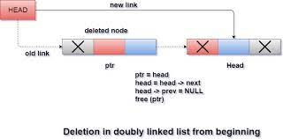
- Function:

- def delete_first(self):
- if not self.head:
- print("\nEmpty List\n")
- return

- # Step 1: Point the head to the next node
- temp = self.head
- self.head = self.head.next

- # Step 2: Set the prev of the new head to None
- if self.head:
- self.head.prev = None

- # Step 3: Free the memory of the old head
- temp.next = None
- del temp

- def display(self):
- if not self.head:
- print("\nList is Empty\n")
- return

- temp = self.head
- print("\nList elements are - ")
- while temp:
- print(f"{temp.data} <=>", end=" ")
- temp = temp.next
- print("NULL")
Deletion a node at end of a double linked lists:
- Assign node trav to the node head.
- Travers the node trav to the last node.
while(trav->next!=NULL)
trav=trav->next
- Prev field of trav is NULL and next field of second last node is NULL.
- Delete the node trav.

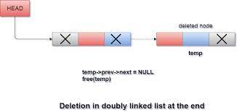
- Function:
- def delete_end(self):
- # Step 1: Check if the list is empty
- if not self.head:
- print("\nList is Empty.\n")
- return

- # Step 2: Traverse to the last node
- temp = self.head
- while temp.next: # Traverse until the last node
- temp = temp.next

- # Step 3: Remove the last node
- if temp.prev:
- temp.prev.next = None # Set the second last node's next to None
- temp.prev = None # Remove the reference from the last node's prev to the second last node
- del temp # Free the memory for the last node

- def display(self):
- # Display the list
- if not self.head:
- print("\nList is Empty.\n")
- return
- temp = self.head
- print("\nList elements are - ")
- while temp:
- print(f"{temp.data} <=>", end=" ")
- temp = temp.next
- print("NULL")
Delete a node at a given position of a Double Linked Lists:
- Assign a node trav to the head.
- Assign : pos
- IF pos=1 the follow the same steps for delete at beginning.
- ELSE: Traverse the node trav till pos-1.
- Assign a node temp=trav->next
- Connect next field of the node trav to the next node of the node temp
- Prev field of the next node of temp to connect to the node trav.
- Assign NULL to prev and next field of the node temp.
- Delete the node temp.
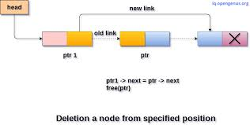
- Function:
- class Node:
- def __init__(self, data):
- self.data = data
- self.prev = None
- self.next = None

- class DoublyLinkedList:
- def __init__(self):
- self.head = None

- def delete_position(self):
- # Step 1: Get the position from the user
- pos = int(input("\nEnter position to delete: "))
- temp = self.head

- # Step 2: Check if the list is empty
- if not self.head:
- print("\nList is Empty.\n")
- return

- # Step 3: If position is 1, delete the first node
- if pos == 1:
- self.head = self.head.next
- if self.head:
- self.head.prev = None
- temp.next = None
- del temp # Free the memory of the deleted node

- # Step 4: Traverse to the position and delete the node
- else:
- i = 1
- while temp and i < pos - 1:
- temp = temp.next
- i += 1

- # If position is out of range
- if temp is None or temp.next is None:
- print("\nInvalid position.\n")
- return

- # Delete the node at the specified position
- r = temp.next
- temp.next = r.next

- if r.next:
- r.next.prev = temp

- r.next = None
- r.prev = None
- del r # Free the memory of the deleted node

- def display(self):
- # Display the list
- if not self.head:
- print("\nList is Empty.\n")
- return
- temp = self.head
- print("\nList elements are - ")
- while temp:
- print(f"{temp.data} <=>", end=" ")
- temp = temp.next
- print("NULL")
Display the value of all the node of a Double Linked Lists:
- Assign a node trav to the head.
- Traverse the node trav till end
While(trav->next != NULL)
- During traversal display data elements of each node.

- Function:
def display(self):
# Step 1: Check if the list is empty
if not self.head:
print("\nList is Empty.\n")
return

# Step 2: Traverse and print the elements
temp = self.head
print("\nList elements are:")
while temp:
print(f"{temp.data}\t", end="")
temp = temp.next
print() # Newline at the end of the list

2.3 Circular Linked List

2.3.1 Session Outcomes:
- Student able to:
  - Understand what is a Circular linked list.
  - How to design a circular linked list.
  - How to create a node and how to link that node to the circular linked list.
  - Perform operations on CLL:

i. Insertion

ii. Deletion

iii. Display

iv. Search

2.3.2 What is Circular Linked List?

- In single linked list, every node points to its next node in the sequence and the last node points NULL. But in circular linked list, every node points to its next node in the sequence but the last node points to the first node in the list.
Definition:A circular linked list is a sequence of elements in which every element has a link to its next element in the sequence and the last element has a link to the first element.
- That means circular linked list is similar to the single linked list except that the last node points to the first node in the list

Example
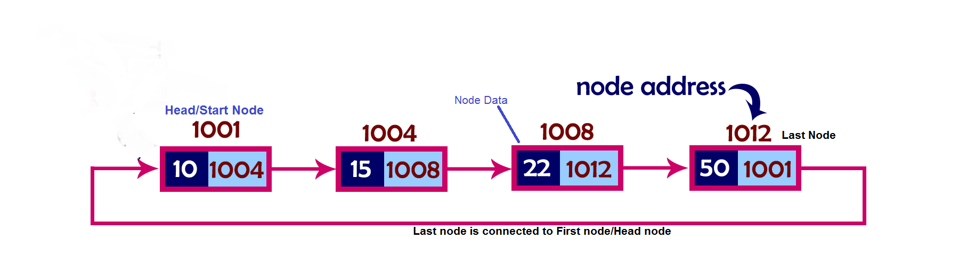

2.3.3 Types of CLL:

  - Circular Singly Linked list
  - Circular Doubly Linked list

1. Circular Singly Linked List
- Here, the address of the last node consists of the address of the first node.
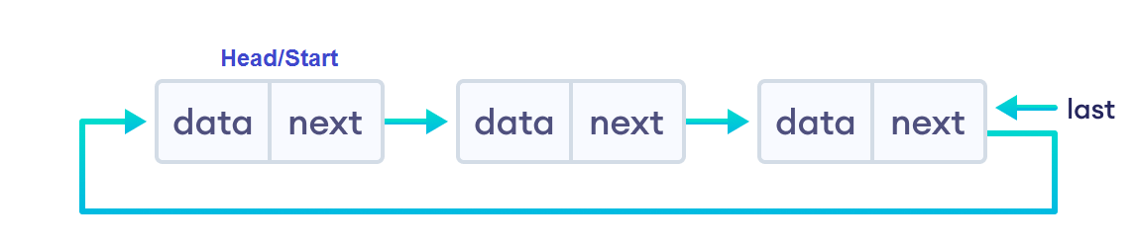
Circular Singly linked list
- Circular Doubly Linked List
- Here, in addition to the last node storing the address of the first node, the first node will also store the address of the last node.
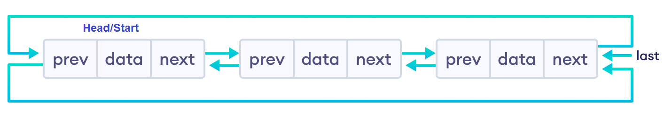
Circular Doubly linked list

2.3.4 Operations on CLL:
- In a circular linked list, we can perform the following operations...
- Insertion
- Deletion
- Display
- Search

Setup the CLL:
- Before we implement those operations, first we need to setup empty list.
Perform the following steps to setup Empty CLL:.
Step 1 - Define a Node structure with two members/fields data and next
Step 2 - Define a Node pointer 'head' and set it to NULL.
Step 3 – Then perform the Operations one by one.
- The node is defined (represented) as:
class Node:
def __init__(self, data):
self.data = data # Store data in the node
self.next = None # Pointer to the next node, initially set to None

# Initialize the head of the linked list to None
head = None

# Example Usage
if head is None:
print("The linked list is empty.")
Insertion:
- Insertion At Beginning of the CLL
- Insertion At End of the CLL
- Insertion At Specific location in the CLL
Insertion At Beginning of the CLL:
- We can insert a new node at beginning(before head node) of the circular linked list.

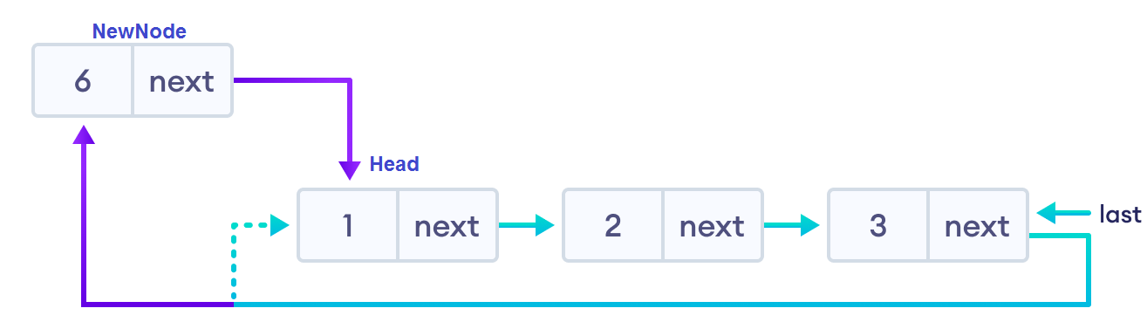

Algorithm:

1. Create a newNode by malloc().

2. Assign a value to the data field.

3. Check whether list is Empty (head == NULL)

3.1 If it is Empty then, set head = newNode and newNode→next = head .

4. If it is Not Empty then, define a Node pointer 'temp' and initialize

temp with 'head'.

4.1 move the 'temp' to its next node until it reaches to the last node (until 'temp → next == head').

4.2 Set 'newNode → next =head', 'head = newNode' and

'temp → next = head'.

Insertion At End of the CLL
- We to insert a new node at end of the circular linked list.

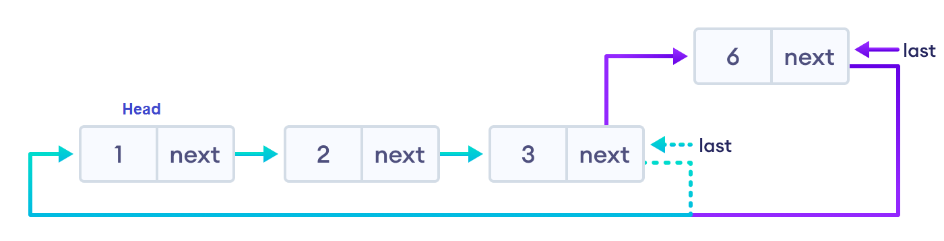
- Create a newNode with given value.
- Check whether list is Empty (head == NULL).

2.1 If it is Empty then, set head = newNode and newNode → next = head.

3. If it is Not Empty then, define a node pointer temp and initialize with head.

3.1 Move the temp to its next node until it reaches to the last node in the list (until temp → next == head).

3.2 Set temp → next = newNode and

newNode → next = head.

Inserting At Specific location in the list
- We need to insert a new node after a specific node in the circular linked list.

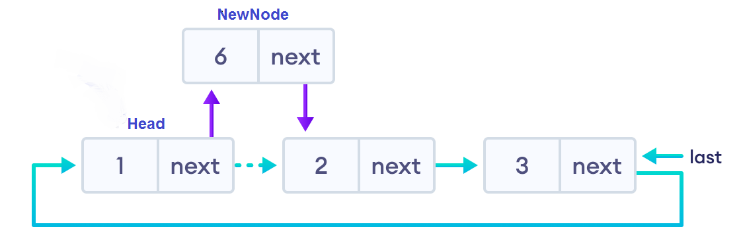

Algorithm:

1. Create a newNode with given value.

2. Check whether list is Empty (head == NULL) or not.

2.1 If it is Empty then, set head = newNode and

newNode → next = head.

4. If it is Not Empty then, define a node pointer temp and

initialize with head.

4.1 Move the temp to its next nodes (based on position or data value of the node).

4.2 If temp is reached to the last node then display'Given node is not found in the list! Insertion not possible!!!' and terminate.

4.3 Otherwise move the temp to next node.

4.4 If temp is reached to the exact node,

then check whether it is last node (temp → next == head) or not.

4.4.1 If temp is last node then

set temp → next = newNode and

newNode → next = head.

4.4.2 If temp is not last node then

setnewNode → next = temp → next and

temp → next = newNode.

Deletion of a node from CLL:
- In a CLL, the deletion operation can be performed in three ways as follows:

i. Deleting from Beginning of the list

ii. Deleting from End of the list

iii. Deleting a Specific Node

- Deleting from Beginning of the list
- We can delete a node from beginning of the CLL.

Algorithm:
- Check whether list is Empty (head == NULL)
- If it is Empty then,

2.1 Display'List is Empty! Deletion is not possible' and terminate.

3. If it is Not Empty then, define two Node pointers 'temp1' and 'temp2' and

initialize both 'temp1' and 'temp2' with head.

3.1 Check whether list is having only one node (temp1 → next == head)

3.1.1 If it is TRUE then

sethead = NULL and

deletetemp1 (Setting Empty list conditions)

3.1.2 If it is FALSE, then, move the temp1 until it reaches to the last node.

(untiltemp1 → next == head )

Then set head = temp2 → next,

temp1 → next = head and

deletetemp2.

Deleting from End(Last node) of the CLL:
- We can delete a node from end of the CLL:

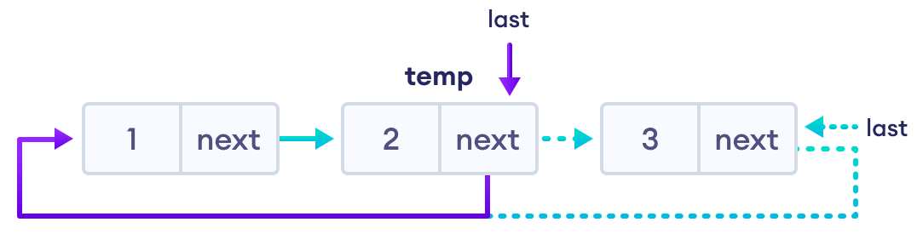

Algorithm:

1. Check whether list is Empty (head == NULL).
- If it is Empty then,

2.1 Display'List is Empty! Deletion is not possible' and terminate.

3. If it is Not Empty then, define two Node pointers 'temp1' and 'temp2' and

initialize 'temp1' with head.

3.1 Check whether list has only one Node (temp1 → next == head)

3.1.1 If it is TRUE. Then,

sethead = NULL and

deletetemp1,.and terminate.

3.1.2 If it is FALSE. Then,

Set 'temp2 = temp1 ' and move temp1 to its next node. Repeat the same until temp1 reaches to the last node in the list. (untiltemp1 → next == head)

Set temp2 → next = head and

deletetemp1.

Deleting a Specific Node from the list
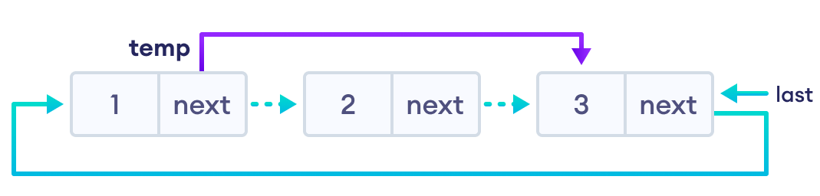
Algorithm:
1. Check whether list is Empty (head == NULL)
2. If it is Empty then,
2.1 Display'List is Empty! Deletion is not possible' and terminate.
3. If it is Not Empty then, define two Node pointers 'temp1' and 'temp2' and initialize 'temp1' with head.
3.1 Keep moving the temp1 until it reaches to the exact node to be deleted or to the last node.
And every time set 'temp2 = temp1' before moving the 'temp1' to its next node.
3.2 If it is reached to the last node then
Display 'Given node not found in the list! Deletion not possible!!!'.and terminate.
3.3 If it is reached to the exact node to be delete, then check whether list is having only one node (temp1 → next == head)
If list has only one node and that is the node to be deleted then
sethead = NULL and
deletetemp1.
3.4 If list contains multiple nodes then check whether temp1 is the first node in the list
(temp1 == head).
3.4.1 If temp1 is the first node then
settemp2 = head and
keep moving temp2 to its next node until temp2 reaches to the last node. Then
sethead = head → next,
temp2 → next = head and
deletetemp1.
3.5 Iftemp1 is not first node then check whether it is last node in the list
(temp1 → next == head).
3.5.1 If temp1 is last node then
settemp2 → next = head and
deletetemp1.
3.6 Iftemp1 is not first node and not last node then
settemp2 → next = temp1 → next and
deletetemp1.

Displaying a circular Linked List:

Displaying the elements of a circular linked list means Printing all the elements of the CLL on the screen.

Algorithm:

Check whether list is Empty (head == NULL)

If it is Empty, then

2.1 Display 'List is Empty!' and terminate.

3. If it is Not Empty then, define a Node pointer 'temp' and initialize with head.

3.1 Keep displaying temp → data with an arrow (--->) until temp reaches to the last node.

3.2 Finally display temp → data with arrow pointing to head → data.

2.3.5 Implementation of Circular Linked List
class Node:
def __init__(self, data):
self.data = data
self.next = None

class CircularLinkedList:
def __init__(self):
self.head = None

# Insert at the beginning
def insert_at_beginning(self, value):
new_node = Node(value)
if not self.head:
self.head = new_node
new_node.next = self.head
else:
temp = self.head
while temp.next != self.head:
temp = temp.next
new_node.next = self.head
self.head = new_node
temp.next = self.head
print("\nInsertion success!")

# Insert at the end
def insert_at_end(self, value):
new_node = Node(value)
if not self.head:
self.head = new_node
new_node.next = self.head
else:
temp = self.head
while temp.next != self.head:
temp = temp.next
temp.next = new_node
new_node.next = self.head
print("\nInsertion success!")

# Insert after a specific node
def insert_after(self, value, location):
new_node = Node(value)
temp = self.head
if not self.head:
self.head = new_node
new_node.next = self.head
else:
while temp:
if temp.data == location:
new_node.next = temp.next
temp.next = new_node
print("\nInsertion success!")
return
if temp.next == self.head:
print("Node not found in the list.")
return
temp = temp.next

# Delete the first node
def delete_beginning(self):
if not self.head:
print("\nList is empty. Deletion not possible.")
return
if self.head.next == self.head:
self.head = None
else:
temp = self.head
while temp.next != self.head:
temp = temp.next
self.head = self.head.next
temp.next = self.head
print("\nDeletion success!")

# Delete the last node
def delete_end(self):
if not self.head:
print("\nList is empty. Deletion not possible.")
return
if self.head.next == self.head:
self.head = None
else:
temp = self.head
while temp.next != self.head:
prev = temp
temp = temp.next
prev.next = self.head
print("\nDeletion success!")

# Delete a specific node
def delete_specific(self, value):
if not self.head:
print("\nList is empty. Deletion not possible.")
return
temp = self.head
prev = None
if temp.data == value:
self.head = temp.next
while temp.next != self.head:
temp = temp.next
temp.next = self.head
print("\nDeletion success!")
return
while temp:
if temp.data == value:
prev.next = temp.next
print("\nDeletion success!")
return
prev = temp
temp = temp.next
if temp == self.head:
print("\nNode not found.")
return

# Display the list
def display(self):
if not self.head:
print("\nList is empty!")
return
temp = self.head
print("\nList elements are: ")
while temp.next != self.head:
print(temp.data, end=" --> ")
temp = temp.next
print(temp.data)

# Example Usage
cll = CircularLinkedList()

# Menu-driven interaction
while True:
print("\n*** MENU ***")
print("1. Insert")
print("2. Delete")
print("3. Display")
print("4. Exit")
choice1 = int(input("Enter your choice: "))

if choice1 == 1:
value = int(input("Enter the value to be inserted: "))
while True:
print("\nSelect from the following Inserting options")
print("1. At Beginning")
print("2. At End")
print("3. After a Node")
print("4. Cancel")
choice2 = int(input("Enter your choice: "))
if choice2 == 1:
cll.insert_at_beginning(value)
break
elif choice2 == 2:
cll.insert_at_end(value)
break
elif choice2 == 3:
location = int(input("Enter the location after which you want to insert: "))
cll.insert_after(value, location)
break
elif choice2 == 4:
break
else:
print("\nPlease select a correct Inserting option!!!")

elif choice1 == 2:
while True:
print("\nSelect from the following Deleting options")
print("1. At Beginning")
print("2. At End")
print("3. Specific Node")
print("4. Cancel")
choice2 = int(input("Enter your choice: "))
if choice2 == 1:
cll.delete_beginning()
break
elif choice2 == 2:
cll.delete_end()
break
elif choice2 == 3:
value = int(input("Enter the Node value to be deleted: "))
cll.delete_specific(value)
break
elif choice2 == 4:
break
else:
print("\nPlease select a correct Deleting option!!!")

elif choice1 == 3:
cll.display()

elif choice1 == 4:
break

else:
print("\nPlease select a correct option!!!")

2.3.5 Circular Linked List Complexity:

Circular Linked List Complexity | Time Complexity
Insertion Operation | O(1) or O(n)
Deletion Operation | O(1)

2.3.6 Advantages of Circular Linked Lists:
1) Any node can be a starting point. We can traverse the whole list by starting from any point. We just need to stop when the first visited node is visited again.
2) Useful for implementation of queue. Unlike this implementation, we don’t need to maintain two pointers for front and rear if we use circular linked list. We can maintain a pointer to the last inserted node and front can always be obtained as next of last.

3) Circular lists are useful in applications to repeatedly go around the list. For example, when multiple applications are running on a PC, it is common for the operating system to put the running applications on a list and then to cycle through them, giving each of them a slice of time to execute, and then making them wait while the CPU is given to another application. It is convenient for the operating system to use a circular list so that when it reaches the end of the list it can cycle around to the front of the list.

4) Circular Doubly Linked Lists are used for implementation of advanced data structures

2.3.7Circular Linked List Applications
- It is used in multiplayer games to give a chance to each player to play the game.
- Multiple running applications can be placed in a circular linked list on an operating system. The os keeps on iterating over these applications.

CO 2

Stack Using Linked List

The major problem with the stack implemented using an array is, it works only for a fixed number of data values. That means the amount of data must be specified at the beginning of the implementation itself. Stack implemented using an array is not suitable, when we don't know the size of data which we are going to use. A stack data structure can be implemented by using a linked list data structure. The stack implemented using linked list can work for an unlimited number of values. That means, stack implemented using linked list works for the variable size of data. So, there is no need to fix the size at the beginning of the implementation. The Stack implemented using linked list can organize as many data values as we want.
In linked list implementation of a stack, every new element is inserted as 'top' element. That means every newly inserted element is pointed by 'top'. Whenever we want to remove an element from the stack, simply remove the node which is pointed by 'top' by moving 'top' to its previous node in the list. The next field of the first element must be always NULL.
Example

In the above example, the last inserted node is 99 and the first inserted node is 25. The order of elements inserted is 25, 32,50 and 99.
Stack Operations using Linked List
To implement a stack using a linked list, we need to set the following things before implementing actual operations.
- Step 1 - Include all the header files which are used in the program. And declare all the user defined functions.
- Step 2 - Define a 'Node' structure with two members data and next.
- Step 3 - Define a Node pointer 'top' and set it to NULL.
- Step 4 - Implement the main method by displaying Menu with list of operations and make suitable function calls in the main method.
push(value) - Inserting an element into the Stack
We can use the following steps to insert a new node into the stack...
- Step 1 - Create a newNode with given value.
- Step 2 - Check whether stack is Empty (top == NULL)
- Step 3 - If it is Empty, then set newNode → next = NULL.
- Step 4 - If it is Not Empty, then set newNode → next = top.
- Step 5 - Finally, set top = newNode.
pop() - Deleting an Element from a Stack
We can use the following steps to delete a node from the stack...
- Step 1 - Check whether stack is Empty (top == NULL).
- Step 2 - If it is Empty, then display "Stack is Empty!!! Deletion is not possible!!!" and terminate the function
- Step 3 - If it is Not Empty, then define a Node pointer 'temp' and set it to 'top'.
- Step 4 - Then set 'top = top → next'.
- Step 5 - Finally, delete 'temp'. (free(temp)).
display() - Displaying stack of elements
We can use the following steps to display the elements (nodes) of a stack...
- Step 1 - Check whether stack is Empty (top == NULL).
- Step 2 - If it is Empty, then display 'Stack is Empty!!!' and terminate the function.
- Step 3 - If it is Not Empty, then define a Node pointer 'temp' and initialize with top.
- Step 4 - Display 'temp → data --->' and move it to the next node. Repeat the same until temp reaches to the first node in the stack. (temp → next != NULL).
- Step 5 - Finally! Display 'temp → data ---> NULL'.
Implementation of Stack using Linked List |
class Node:
def __init__(self, data):
self.data = data
self.next = None

class Stack:
def __init__(self):
self.top = None

# Push operation
def push(self, value):
new_node = Node(value)
if self.top is None:
self.top = new_node
else:
new_node.next = self.top
self.top = new_node
print("\nInsertion is Success!!!")

# Pop operation
def pop(self):
if self.top is None:
print("\nStack is Empty!!!")
else:
temp = self.top
print("\nDeleted element:", temp.data)
self.top = temp.next
del temp

# Display the stack
def display(self):
if self.top is None:
print("\nStack is Empty!!!")
else:
temp = self.top
while temp:
print(f"{temp.data}--->", end="")
temp = temp.next
print("NULL")

# Example Usage
stack = Stack()

# Menu-driven interaction
while True:
print("\n****** MENU ******")
print("1. Push")
print("2. Pop")
print("3. Display")
print("4. Exit")
choice = int(input("Enter your choice: "))

if choice == 1:
value = int(input("Enter the value to be inserted: "))
stack.push(value)
elif choice == 2:
stack.pop()
elif choice == 3:
stack.display()
elif choice == 4:
break
else:
print("\nWrong selection!!! Please try again!!!")

Stack as we know is a Last In First Out(LIFO) data structure. It has the following operations :
- push: push an element into the stack
- pop: remove the last element added
- top: returns the element at top of stack

Conclusion
When we say "implementing Stack using Linked List", we mean how we can make a Linked List behave like a Stack, after all they are all logical entities. So for any data structure to act as a Stack, it should have push() method to add data on top and pop() method to remove data from top. Which is exactly what we did and hence accomplished to make a Linked List behave as a Stack.

CO 2 (2.3 Stack applications)

Application of Stack Data Structure:

- Evaluation of Arithmetic Expressions
- Backtracking
- Delimiter Checking
- Reverse a Data
- Processing Function Calls
- Evaluation of Arithmetic expressions:
stack is a very effective data structure for evaluating arithmetic expressions in programming languages. An arithmetic expression consists of operands and operators.
Example: A + (B - C)
To evaluate the expressions, one needs to be aware of the standard precedence rules for arithmetic expression. The precedence rules for the five basic arithmetic operators are:
Operators | Associativity | Precedence
^ exponentiation | Right to left | Highest followed by *Multiplication and /division
*Multiplication, /division | Left to right | Highest followed by + addition and - subtraction
+ addition, - subtraction | Left to right | lowest

Evaluation of Arithmetic Expression requires two steps:
- First, convert the given expression into special notation.
- Evaluate the expression in this new notation.

Notations for Arithmetic Expression
There are three notations to represent an arithmetic expression:
- Infix Notation
- Prefix Notation
- Postfix Notation
Infix Notation
The infix notation is a convenient way of writing an expression in which each operator is placed between the operands. Infix expressions can be parenthesized or unparenthesized depending upon the problem requirement.
Example: A + B, (C - D) etc.
All these expressions are in infix notation because the operator comes between the operands.
Prefix Notation
The prefix notation places the operator before the operands. This notation was introduced by the Polish mathematician and hence often referred to as polish notation.
Example: + A B, -CD etc.
All these expressions are in prefix notation because the operator comes before the operands.
Postfix Notation
The postfix notation places the operator after the operands. This notation is just the reverse of Polish notation and also known as Reverse Polish notation.
Example: AB +, CD+, etc.
All these expressions are in postfix notation because the operator comes after the operands.
Conversion of Arithmetic Expression into various Notations:
Infix Notation | Prefix Notation | Postfix Notation
A * B | * A B | AB*
(A+B)/C | /+ ABC | AB+C/
(A*B) + (D-C) | +*AB - DC | AB*DC-+
Let's take the example of Converting an infix expression into a postfix expression.
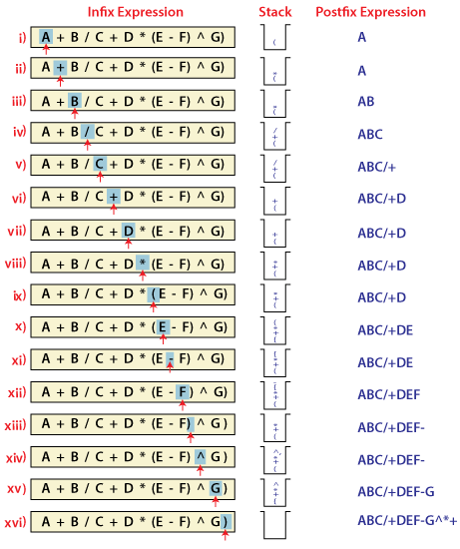
In the above example, the only change from the postfix expression is that the operator is placed before the operands rather than between the operands.

IMPLEMENTATION OF POSTFIX TO PREFIX NOTATION:
- Push “(“onto Stack, and add “)” to the end of X.
- Scan X from left to right and repeat Step 3 to 6 for each element of X until the Stack is empty.
- If an operand is encountered, add it to Y.
- If a left parenthesis is encountered, push it onto Stack.
- If an operator is encountered ,then:
  - Repeatedly pop from Stack and add to Y each operator (on the top of Stack) which has the same precedence as or higher precedence than operator.
  - Add operator to Stack.
[End of If]
- If a right parenthesis is encountered ,then:
  - Repeatedly pop from Stack and add to Y each operator (on the top of Stack) until a left parenthesis is encountered.
  - Remove the left Parenthesis.
[End of If]
[End of If]
- END.
PROGRAM:
class Stack:
def __init__(self):
self.stack = []

def push(self, item):
self.stack.append(item)

def pop(self):
if len(self.stack) > 0:
return self.stack.pop()
else:
return None

def top(self):
if len(self.stack) > 0:
return self.stack[-1]
else:
return None

def is_empty(self):
return len(self.stack) == 0

# Function to check precedence of operators
def precedence(operator):
if operator == '^':
return 3
elif operator == '*' or operator == '/':
return 2
elif operator == '+' or operator == '-':
return 1
else:
return 0

# Function to check if character is an operator
def is_operator(c):
return c in ['+', '-', '*', '/', '^']

# Function to convert infix expression to postfix
def infix_to_postfix(infix_exp):
stack = Stack()
postfix_exp = []

infix_exp = '(' + infix_exp + ')'
i = 0
while i < len(infix_exp):
item = infix_exp[i]

if item == '(':
stack.push(item)

elif item.isdigit() or item.isalpha(): # operand (numbers or variables)
postfix_exp.append(item)

elif is_operator(item): # operator
while (not stack.is_empty() and is_operator(stack.top()) and
precedence(stack.top()) >= precedence(item)):
postfix_exp.append(stack.pop())
stack.push(item)

elif item == ')':
while stack.top() != '(':
postfix_exp.append(stack.pop())
stack.pop() # Pop '(' from the stack

else: # Invalid character
print("\nInvalid infix expression.")
exit(1)

i += 1

return ''.join(postfix_exp)

# Example usage
infix = "A+B*(C^D-E)^(F+G*H)-I"
postfix = infix_to_postfix(infix)
print(f"Infix Expression: {infix}")
print(f"Postfix Expression: {postfix}")

Evaluating Postfix expression:
Stack is the ideal data structure to evaluate the postfix expression because the top element is always the most recent operand. The next element on the Stack is the second most recent operand to be operated on.
Before evaluating the postfix expression, the following conditions must be checked. If any one of the conditions fails, the postfix expression is invalid.
- When an operator encounters the scanning process, the Stack must contain a pair of operands or intermediate results previously calculated.
- When an expression has been completely evaluated, the Stack must contain exactly one value.
Example:
Now let us consider the following infix expression 2 * (4+3) - 5.
Its equivalent postfix expression is 2 4 3 + * 5.
The following step illustrates how this postfix expression is evaluated.
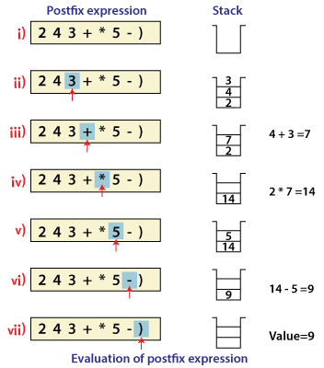

2. Backtracking
Backtracking is another application of Stack. It is a recursive algorithm that is used for solving the optimization problem.

3. Delimiter Checking
The common application of Stack is delimiter checking, i.e., parsing that involves analyzing a source program syntactically. It is also called parenthesis checking. When the compiler translates a source program written in some programming language such as C, C++ to a machine language, it parses the program into multiple individual parts such as variable names, keywords, etc. By scanning from left to right. The main problem encountered while translating is the unmatched delimiters. We make use of different types of delimiters include the parenthesis checking (,), curly braces {,} and square brackets [,], and common delimiters /* and */. Every opening delimiter must match a closing delimiter, i.e., every opening parenthesis should be followed by a matching closing parenthesis. Also, the delimiter can be nested. The opening delimiter that occurs later in the source program should be closed before those occurring earlier.
Valid Delimiter | Invalid Delimiter
While ( i > 0) | While ( i >
/* Data Structure */ | /* Data Structure
{ ( a + b) - c } | { ( a + b) - c
To perform a delimiter checking, the compiler makes use of a stack. When a compiler translates a source program, it reads the characters one at a time, and if it finds an opening delimiter it places it on a stack. When a closing delimiter is found, it pops up the opening delimiter from the top of the Stack and matches it with the closing delimiter.
On matching, the following cases may arise.
- If the delimiters are of the same type, then the match is considered successful, and the process continues.
- If the delimiters are not of the same type, then the syntax error is reported.
When the end of the program is reached, and the Stack is empty, then the processing of the source program stops.
Example: To explain this concept, let's consider the following expression.
[{a -b) * (c -d)}/f]

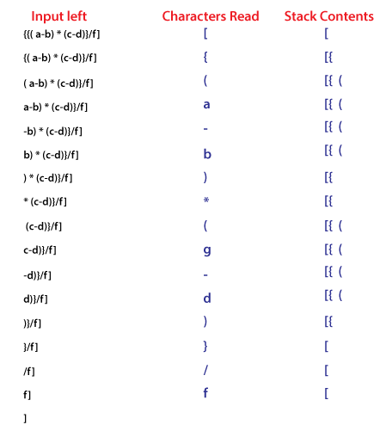

4. Reverse a Data:
To reverse a given set of data, we need to reorder the data so that the first and last elements are exchanged, the second and second last element are exchanged, and so on for all other elements.
Example: Suppose we have a string Welcome, then on reversing it would be Emoclew.
There are different reversing applications:
- Reversing a string
- Converting Decimal to Binary

Reverse a String
A Stack can be used to reverse the characters of a string. This can be achieved by simply pushing one by one each character onto the Stack, which later can be popped from the Stack one by one. Because of the last in first out property of the Stack, the first character of the Stack is on the bottom of the Stack and the last character of the String is on the Top of the Stack and after performing the pop operation in the Stack, the Stack returns the String in Reverse order.
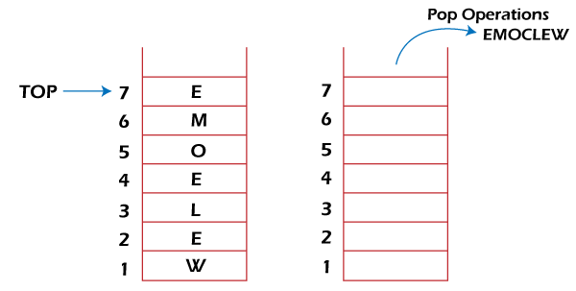

Converting Decimal to Binary:
Although decimal numbers are used in most business applications, some scientific and technical applications require numbers in either binary, octal, or hexadecimal. A stack can be used to convert a number from decimal to binary/octal/hexadecimal form. For converting any decimal number to a binary number, we repeatedly divide the decimal number by two and push the remainder of each division onto the Stack until the number is reduced to 0. Then we pop the whole Stack and the result obtained is the binary equivalent of the given decimal number.

Example: Converting 14 number Decimal to Binary:
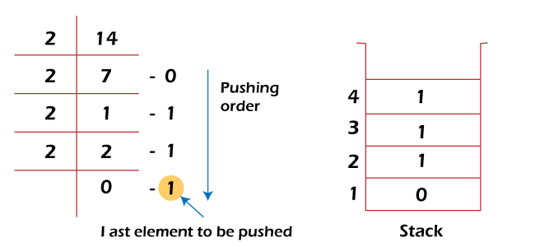
In the above example, on dividing 14 by 2, we get seven as a quotient and one as the reminder, which is pushed on the Stack. On again dividing seven by 2, we get three as quotient and 1 as the reminder, which is again pushed onto the Stack. This process continues until the given number is not reduced to 0. When we pop off the Stack completely, we get the equivalent binary number 1110.

5. Processing Function Calls:
Stack plays an important role in programs that call several functions in succession. Suppose we have a program containing three functions: A, B, and C. function A invokes function B, which invokes the function C.
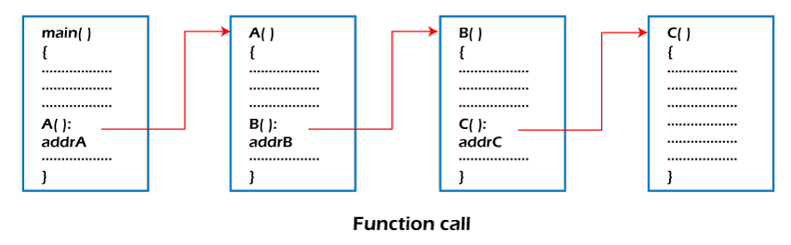
When we invoke function A, which contains a call to function B, then its processing will not be completed until function B has completed its execution and returned. Similarly for function B and C. So we observe that function A will only be completed after function B is completed and function B will only be completed after function C is completed. Therefore, function A is first to be started and last to be completed. To conclude, the above function activity matches the last in first out behavior and can easily be handled using Stack.
Consider addrA, addrB, addrC be the addresses of the statements to which control is returned after completing the function A, B, and C, respectively.
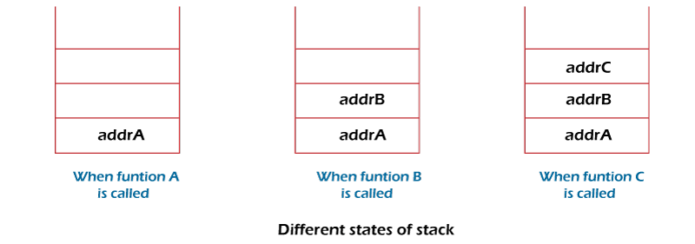
The above figure shows that return addresses appear in the Stack in the reverse order in which the functions were called. After each function is completed, the pop operation is performed, and execution continues at the address removed from the Stack. Thus the program that calls several functions in succession can be handled optimally by the stack data structure. Control returns to each function at a correct place, which is the reverse order of the calling sequence.

Application of Stack in real life:

- CD/DVD stand.
- Stack of books in a book shop.
- Undo and Redo mechanism in text editors.
- The history of a web browser is stored in the form of a stack.
- Call logs, E-mails, and Google photos in any gallery are also stored in form of a stack.
- YouTube downloads and Notifications are also shown in LIFO format (the latest appears first ).

PRIORITY QUEUE MATERIAL

- Definition: Priority queue is an abstract data type that is similar to a queue and every element some priority value associated with it .
- The priority of the elements in a priority queue determines the order in which elements are served.
- If any case the elements have same priority they are served as their ordering in the queue.
PROPERTIES OF PRIORITY QUEUE
- A priority queue is an extension of the queue with the below properties .
- Every element has a priority associated with it.
- An element high priority is dequeued before an element with low priority .
- If two elements have the priority they are served according to the their order in the queue.
- Algorithm for implementing Priority Queue using Binary Heap
- Step1: Create a function heapify() to heapify the elements in the Binary Tree if any changes are made.
- Step2: Find the largest among root, left child, and right child, then recursively call the same function until the root element matches the largest element.
- Step3: Create a function insert() to insert an element into the tree, which takes an array and the number which is to be inserted as input.
- Step 4: If the size of the array is zero, then this number will be the root, else append the number and call the heapify function recursively to heapify the elements.
- Step5: Create a function deleteNode() that deletes the selected element from the tree
- Step 6: Delete the element and again heapify the elements recursively.
- Step 7: Insert elements into an empty array using the insert() function then try deleting an element from the tree.
- Let us consider a sample priority queue , an element with a maximum ascii value will have the highest priority.
- The elements with higher priority are served first.
- Initial queue = { }
Operation | Return value | Queue content
Insert (c) |  | C
Inset (O) |  | C O
Inset (D) |  | C O D
Remove max | O | C D
Insert (I) |  | C D I
Inset(N) |  | C D I N
Remove Max | N | C D I
Insert(G) |  | C D I G
PROCESS OF ASSIGNING ELEMENTS IN A PRIORITY QUEUE BASED ON THE PRIORITY
- In priority queue generally the value of the element is considered for assigning the priority for example the element with the highest value is assigned with highest priority and the element with the lowest value is assigned with the lowest priority.
- The reverse case can also be used i.e, the element with the lowest value can be assigned with the highest priority.
- Also the priority can be assigned according to our needs.
PRIORITY QUEUE SUPPORTS THE FOLLOWING OPERATIONS
- Insertion in a priority queue
- Deletion in a priority queue
- Peek in a priority queue
APPLICATIONS OF PRIORITY QUEUE
1.CPU Scheduling
2.All queue applications where priority is involved
3.Stack Implementation
4.Event-driven simulation such as customers waiting in a queue
5.Finding Kth largest or smallest element

- For example, you have six numbers in the priority queue that are 4, 8, 12, 45, 35, 20.
- Firstly, you will arrange these numbers in ascending order.
- The new list is as follows: 4, 8, 12, 20. 35, 45.
- In this list, 4 is the smallest number. Hence, the ascending order priority queue treats number 4 as the highest priority.
- In the above table, 4 has the highest priority, and 45 has the lowest priority.
- For example, you have six numbers in the priority queue that are 4, 8, 12, 45, 35, 20.
- Firstly, you will arrange these numbers in ascending order.
- The new list is as follows: 45, 35, 20, 12, 8, 4. In this list, 45 is the highest number.
- Hence, the descending order priority queue treats number 45 as the highest priority.
45 | 35 | 20 | 12 | 8 | 4

- In the above table, 4 has the lowest priority, and 45 has the highest priority.

What is Heap Data Structure?
A Heap is a special Tree-based data structure in which the tree is a complete binary tree
Operations of Heap Data Structure:
- Heapify: a process of creating a heap from an array.
- Insertion: process to insert an element in existing heap time complexity O(log N).
- Deletion: deleting the top element of the heap or the highest priority element, and then organizing the heap and returning the element with time complexity O(log N).
- Peek: to check or find the most prior element in the heap, (max or min element for max and min heap).

Types of Heap Data Structure
Generally, Heaps can be of two types:
- Max-Heap: In a Max-Heap the key present at the root node must be greatest among the keys present at all of it’s children. The same property must be recursively true for all sub-trees in that Binary Tree. The value of each node is greater than or equal to the value of its parent, with the minimum value at the root.
Example
2.Min-Herootap: In a Min-Heap the key present at the node must be minimum among the keys present at all of it’s children. The same property must be recursively true for all sub-trees in that Binary Tree. The value of each node is less than or equal to the value of its parent, with the maximum value at the root.

A Binary Heap is a Binary Tree with following properties.
1) It’s a complete tree (All levels are completely filled except possibly the last level and the last level has all keys as left as possible). This property of Binary Heap makes them suitable to be stored in an array.
2) A Binary Heap is either Min Heap or Max Heap. In a Min Binary Heap, the key at root must be minimum among all keys present in Binary Heap. The same property must be recursively true for all nodes in Binary Tree. Max Binary Heap is similar to Min Heap.

How is Binary Heap represented?
A Binary Heap is a Complete Binary Tree. A binary heap is typically represented as an array.
The root element will be at Arr[0].
Below table shows indexes of other nodes for the i^{th} node, i.e., Arr[i]:
Arr[(i-1)/2] Returns the parent node
Arr[(2*i)+1] Returns the left child node
Arr[(2*i)+2] Returns the right child node
The traversal method use to achieve Array representation is Level Order
[Text Wrapping Break]
Operations on Min Heap:
1) getMini(): It returns the root element of Min Heap. Time Complexity of this operation is O(1).
2) extractMin(): Removes the minimum element from MinHeap. Time Complexity of this Operation is O(Logn) as this operation needs to maintain the heap property (by calling heapify()) after removing root.
3) decreaseKey(): Decreases value of key. The time complexity of this operation is O(Logn). If the decreases key value of a node is greater than the parent of the node, then we don’t need to do anything. Otherwise, we need to traverse up to fix the violated heap property.
4) insert(): Inserting a new key takes O(Logn) time. We add a new key at the end of the tree. IF new key is greater than its parent, then we don’t need to do anything. Otherwise, we need to traverse up to fix the violated heap property.
5) delete(): Deleting a key also takes O(Logn) time. We replace the key to be deleted with minum infinite by calling decreaseKey(). After decreaseKey(), the minus infinite value must reach root, so we call extractMin() to remove the key.
Applications of Heaps:
1) Heap Sort: Heap Sort uses Binary Heap to sort an array in O(nLogn) time.
2) Priority Queue: Priority queues can be efficiently implemented using Binary Heap because it supports insert(), delete() and extractmax(), decreaseKey() operations in O(logn) time. Binomial Heap and Fibonacci Heap are variations of Binary Heap. These variations perform union also efficiently.
3) Graph Algorithms: The priority queues are especially used in Graph Algorithms like Dijkstra’s Shortest Path and Prim’s Minimum Spanning Tree.
SUMMARY
- Introduction to binary heap
- Operations of binary heap
- Applications of binary heap
- Types of binary heap

